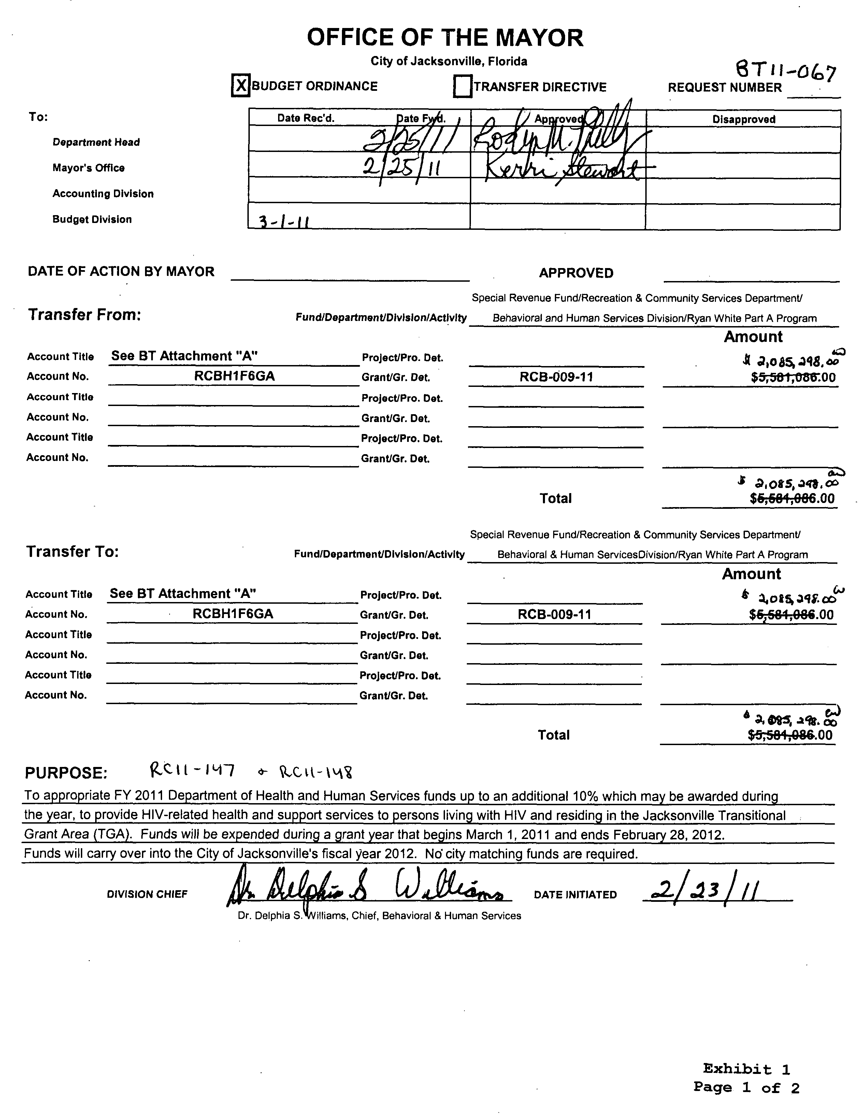Introduced by the Council President at the request of the Mayor:

ORDINANCE 2011-160
AN ORDINANCE REGARDING A CONTINUATION GRANT; APPROPRIATING $2,085,298 IN DEPARTMENT OF HEALTH AND HUMAN SERVICES GRANT FUNDS FROM THE RYAN WHITE PART A PROGRAM, WITH NO MATCHING FUNDS FROM THE CITY OF JACKSONVILLE REQUIRED, TO PROVIDE HIV-RELATED HEALTH AND SUPPORT SERVICES TO PERSONS LIVING WITH HIV/AIDS AND RESIDING IN THE JACKSONVILLE TRANSITIONAL GRANT AREA (TGA), AS INITIATED BY B.T. 11-067, SUCH FUNDS TO BE EXPENDED DURING A GRANT YEAR THAT BEGINS MARCH 1, 2011, AND ENDS FEBRUARY 28, 2012; PROVIDING A CARRYOVER OF FUNDS TO CITY OF JACKSONVILLE FISCAL YEAR 2011-2012; APPROVING POSITION CHANGES IN THE DEPARTMENT OF RECREATION AND COMMUNITY SERVICES, AS INITIATED BY R.C. 11-147 AND R.C. 11-148; PROVIDING FOR CITY OVERSIGHT BY THE DEPARTMENT OF RECREATION AND COMMUNITY SERVICES; REQUESTING EMERGENCY PASSAGE; PROVIDING AN EFFECTIVE DATE.

BE IT ORDAINED by the Council of the City of Jacksonville:
Section 1. Appropriation. For the grant year beginning March 1, 2011, and ending February 28, 2012, and for the 2010-2011 fiscal year, within the City’s budget, there are hereby appropriated the indicated sum(s) from the account(s) listed in subsection (a) to the account(s) listed in subsection (b):
(B.T. 11-067, attached hereto as Exhibit 1 and incorporated herein by this reference)
(a) Appropriated from:
See B.T. 11-067 $2,085,298
- Appropriated to:
See B.T. 11-067 $2,085,298
Section 2. Carryover. The funds appropriated in this ordinance shall not lapse but shall carryover to City of Jacksonville fiscal year 2011-2012.
Section 3. Purpose. The purpose of the appropriation in Section 1 is to provide HIV-related health and support services to persons living with HIV/AIDS and residing in the Jacksonville Transitional Grant Area (TGA). A copy of the Notice of Grant Award is attached hereto as Exhibit 2 and incorporated herein by this reference.
Section 4. Approval of Position Changes. There are hereby approved the position changes more fully described in R.C. 11-147 and R.C. 11-148, attached hereto as Exhibit 3 and incorporated herein by this reference.
Section 5. Oversight Department. The Department of Recreation and Community Services shall oversee the project described herein.
Section 6. Requesting Emergency Passage, Pursuant to Council Rules 4.901 Emergency. Emergency passage of this legislation is requested. The nature of the emergency is that the grant year begins March 1, 2011.
Section 7. Effective Date. This ordinance shall become effective upon signature by the Mayor or upon becoming effective without the Mayor’s signature.

Form Approved:

/s/ James R. McCain, Jr.
Office of General Counsel
Legislation Prepared By: James R. McCain, Jr.
/tmp/in/input.doc

